**31**

**Inductance**

|  |
| --- |
| **CHAPTER OUTLINE** |

31.1 Self-Induction and Inductance

31.2 *RL* Circuits

31.3 Energy in a Magnetic Field

31.4 Mutual Inductance

31.5 Oscillations in an *LC* Circuit

31.6 The *RLC* Circuit

* An asterisk indicates a question or problem new to this edition.

|  |
| --- |
| **ANSWERS TO THINK – PAIR – SHARE PROBLEMS** |

**\*TP31.1 Conceptualize** Let’s remove the complicating features of the various switches. With switch S3 closed, the circuit is like that shown below, where we have explicitly indicated the resistance of the inductor in series with an ideal, resistance-free inductor. The path with the switch is a resistance-free short circuit across the inductor.

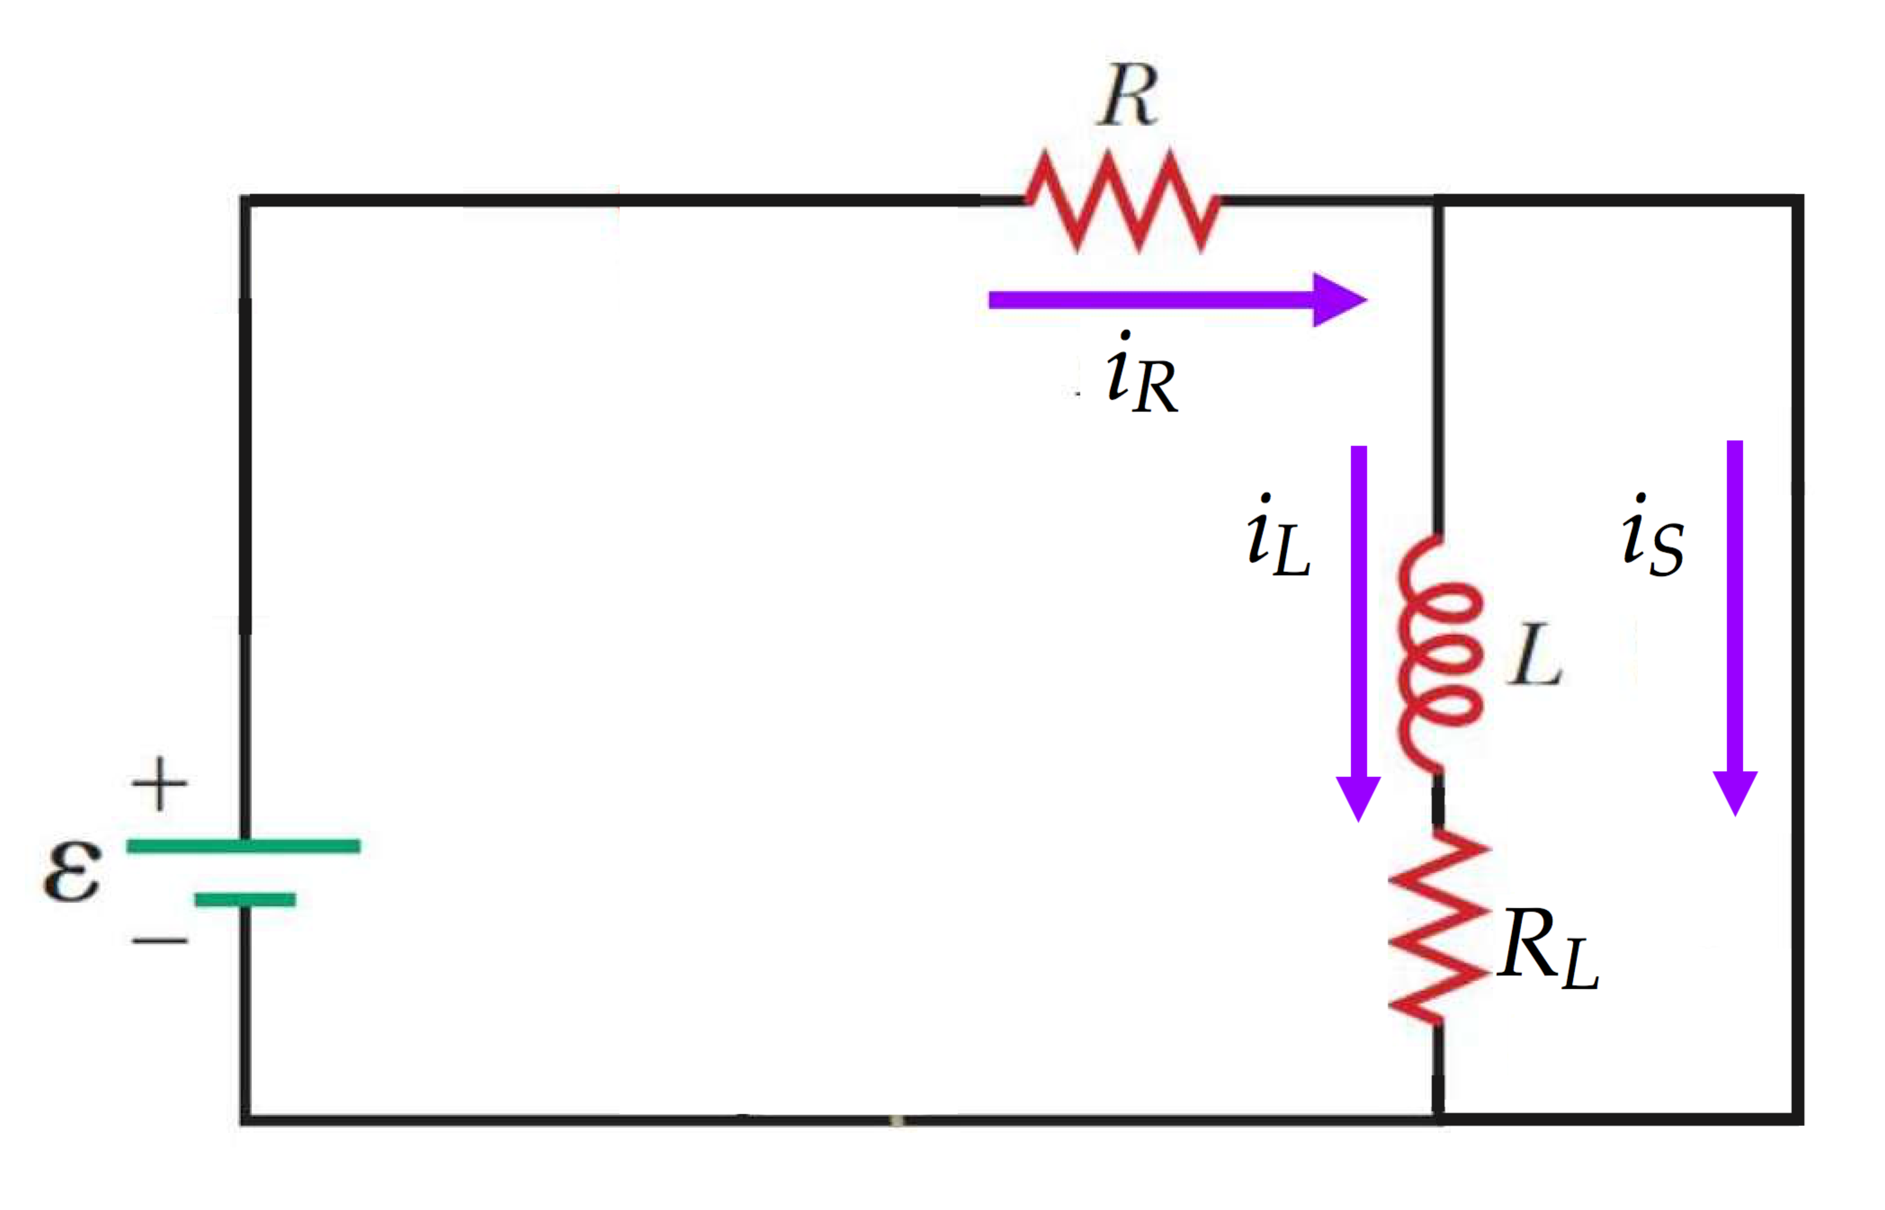

**Categorize** The circuit is an *RL* circuit, which can be analyzed with Kirchhoff’s rules.

**Analyze** (a) Apply Kirchhoff’s loop rule to the outer loop of the circuit:

 (1)

where the equation does not include *iS* because that current is not carried by a circuit element and, therefore, does not generate a potential difference. Therefore, the current in the resistor *R* is constant in time:

 (2)

(b) Now, apply Kirchhoff’s loop rule to the right-hand loop of the circuit:

 (3)

Rearrange the equation in preparation for integration, and then integrate:



Just before switch S3 is closed, the current in the left loop of the circuit is

 (5)

Substituting Equation (5) into Equation (4),

 (6)

(c) Applying Kirchhoff’s junction rule to the junction to the right of *R*, we see that

 (7)

Substitute Equations (2) and (6) into Equation (7):

 (8)

(d) Let *t* go to zero in Equation (8):

 (9)

**Finalize** The current in the resistor *R* is constant. Only the currents in the inductor and the switch change in time. Notice that, after a long time, the current in the switch (Equation (8)) is the same as that in the resistor *R* (Equation (2)). The inductor has an emf across it when the current is changing, but eventually the current reaches a steady state and the inductor has no effect on the circuit. Even though the battery is connected across the internal resistance of the inductor in this steady-state situation, the current in the inductor is zero because there is a zero-resistance wire connected in parallel with it. With no current in the inductor, there is no potential difference across the resistance of its windings.

*Answers:* (a)  (b)  (c) 

(d) 

**\*TP31.2 Conceptualize** Be sure you are clear on Figure 31.15 and what is happening in the circuit. When you throw the switch to position *b*, the battery is removed from the circuit and the circuit undergoes damped oscillations.

**Categorize** We categorize the circuit as an *RLC* circuit, so we can use the material discussed in Section 31.6.

**Analyze** Equation 31.26 gives the theoretical charge on the capacitor as a function of time. Therefore, the voltage across the capacitor is

 (1)

where we have recognized that the maximum voltage on the capacitor was that of the battery when the switch was at position *a*.

(a) Because the voltage on the capacitor is ** at *t* = 0, we see from the graph that



(b) To find the relationship between *L* and *R*, draw a smooth exponential curve following the peaks of the voltage curve, like in Figure 31.15a. For our data, the graph with the exponential curve added looks like Fig. ANS TP31.2a.

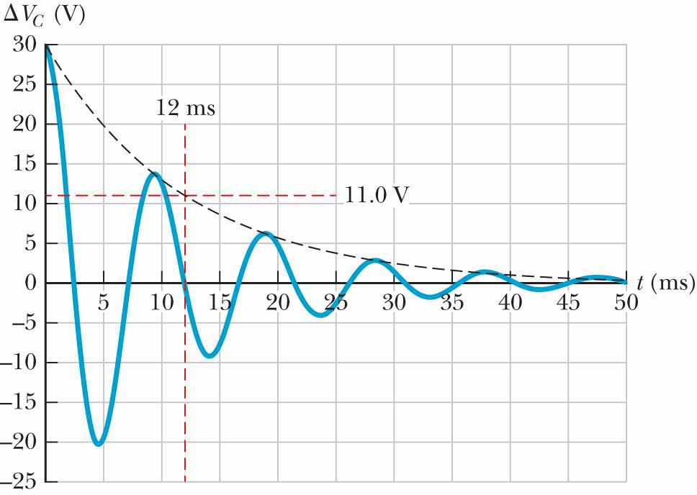

**ANS. FIG. TP31.2 a**

Also seen on the graph is a red line indicating 11.0 V, which is the voltage corresponding to *e*–1. Therefore, this voltage would occur (ignoring the cosine fluctuations) at the time *t* = **, where ** is the time constant. From the graph, we see, then, that the time constant is 12 ms. We keep only two significant figures due to the estimation necessary to read the graph. From the exponential factor in Equation 31.26, we see that the time constant is

 (2)

This process has allowed us to find something about the ratio of *L* to *R*, but we cannot find either one from this relationship alone.

Now, let’s consider Equation 31.27, which also relates to *L* and *R*. This equation gives the frequency of the oscillations. Let’s look back at the graph and find each crossing of the curve with the *t* axis that occurs after the curve has reached a maximum (see Fig. ANS TP31.2b):

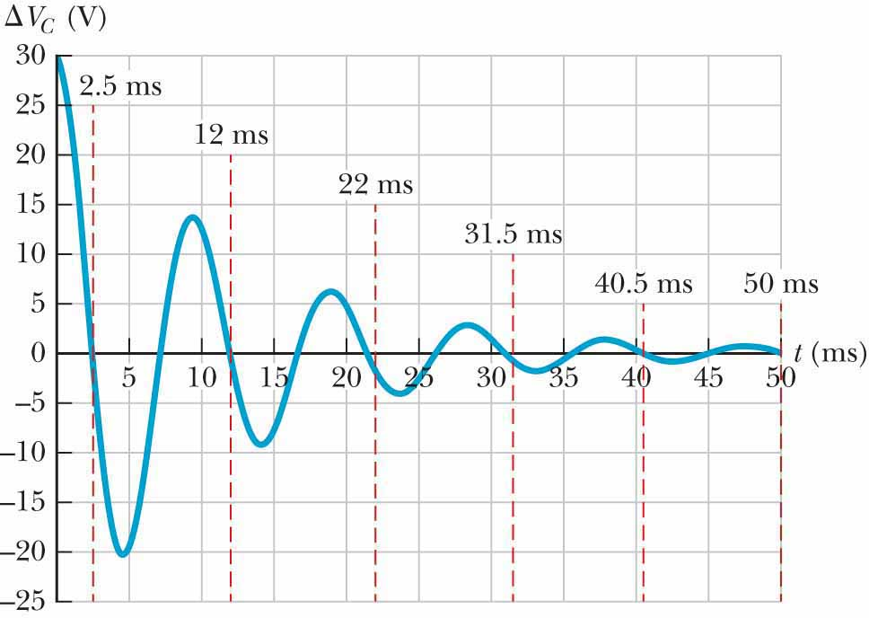

**ANS. FIG. TP31.2 b**

Now let’s tabulate these times and take the difference between adjacent times:

|  |  |
| --- | --- |
| ***t* (ms)** | **∆*t* (ms)** |
| 2.5 |  |
| 12 | 9.5 |
| 22 | 10 |
| 31.5 | 9.5 |
| 40.5 | 9 |
| 50 | 9.5 |

From these data, it appears that the period of the oscillations is *T* = 9.5 ms.

Express Equation 31.27 in terms of the period of the oscillations and the time constant:

 (3)

Solve Equation (3) for the inductance *L*:

 (4)

Substitute numerical values:



(c) Solve Equation (2) for the resistance:

 (5)

Substitute numerical values:



**Finalize** Your answers may differ from these a bit due to the reading of the graph, which is an estimation process.

*Answers:* Answer will vary due to estimation, but typical values are: (a) 30.0 V (b) 0.15 H (c) 25 

|  |
| --- |
| **SOLUTIONS TO END-OF-CHAPTER PROBLEMS** |

Section 31.1 Self-Induction and Inductance

**P31.1** The self-induced emf at any instant is



Its average value is



**P31.2** Treating the telephone cord as a solenoid, we have:



**P31.3** From  we have



From  we have



**P31.4** (a) 

(b) 

(c) 

(d) 

**P31.5** The emf is given by



from which we obtain



If we require  as , the solution is  so



**P31.6** The inductance of a solenoid is 

The long solenoid is bent into a circle of radius *R*, so its length  therefore, the inductance of the toroid is



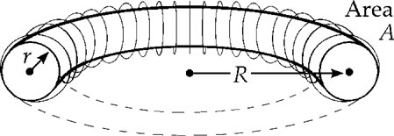

**ANS. FIG. P31.6**

**P31.7** Using the definition of self-inductance,  we obtain





**P31.8** The current change is linear, so 

*t* = 0 to 4 ms:



*t* = 4 to 8 ms:



*t* = 8 to 10 ms:



*t* = 10 to 12 ms:



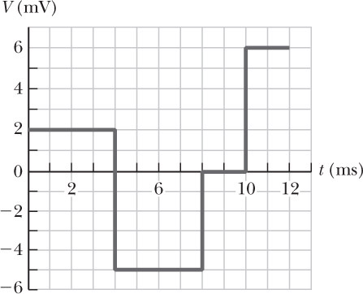

**ANS. FIG. P31.8**

**\*P31.9** **Conceptualize** You may have seen wire wrapped uniformly around cardboard tubes at a home store or hardware store. They represent ready-made inductors!

**Categorize** We can find the results using equations in Section 31.1, so we will categorize the problem as a substitution problem.

(a) Use Equation 31.4 to find the inductance:



(b) Use Equation 31.1 to find the emf:



**Section 31.2 *RL* Circuits**

**P31.10** (a) The inductance of a solenoid is



(b) The time constant of the circuit is



P31.11 ((a) Using , we get

 .

(b) The time constant is



**P31.12** Taking 

 will be true if 

We have agreement because 

**P31.13** For the increasing current  The final value is  so the condition on  is



At the moment when the battery is removed, the current in the coil is quite precisely  During the decrease, 

(a) at 



(b) at 



*P31.14 **Conceptualize** When the switch is closed, current exists in both resistors and the inductor. The current is in the downward direction in Figure P31.14 in the lightbulb and the inductor. When the switch is opened, the inductor provides an emf in the opposite direction as the battery, so as to try to keep the current going. This current will exist in the lightbulb, causing it to glow, with the current being in the upward direction in Figure P31.14.

**Categorize** We model the circuit as an *RL* circuit.

**Analyze** (a) Imagine that the switch in Figure P31.14 has been closed a long time. The current is steady, so the inductor offers no resistance in the circuit, and the current in the inductor is the same as that in *R*2:

 (1)

Now imagine opening the switch. The circuit now is just the singleloop in Figure P31.14 containing the lightbulb, the resistor *R*2, and the inductor. The inductor will provide an emf causing a time-varying current *i* in the clockwise direction. Apply Kirchhoff’s loop rule to this branch, traveling in the clockwise direction:

 (2)

Rearrange this equation to prepare for integration:

 (3)

Integrate Equation (3):



Now we want the instantaneous power in the lightbulb to be its “normal” value, that is, its value when operating at 120 V, *P*normal = 40.0 W at the moment the switch is opened:

 (5)

where we have recognized that the initial current in the lightbulb is the same as that in *R*2, which is the same as the steady current in *R*2 before the switch was opened. Substitute Equation (1) into Equation (5):

 (6)

Evaluate *R*1 from its normal operating conditions:

 (7)

Substitute Equation (7) into Equation (6):

 (8)

Substitute numerical values:



(b) The time constant for the circuit with the switch open can be found from Equation (4), and then we can find the inductance *L*:

 (9)

Use Equation (4) to impose the requirement that the current drop to 50.0% of its initial value at 2.00 s:

 (10)

Substitute Equation (10) into Equation (9) and substitute numerical values of the resistances:



**Finalize** This is a very large inductance, as would be expected to keep a large current going in an incandescent light bulb for a time interval of several seconds. In addition, the resistance of an incandescent light bulb does vary with temperature, an effect we did not address in this problem. You might suggest redesigning the demonstration apparatus to employ an LED as the light source.

*Answers:* (a) 36.0  (b) 1.14 kH

**P31.15** Name the currents as shown in ANS. FIG. P31.15. By Kirchhoff’s laws:

*i*1 = *i*2 + *i*3 **[1]**

+10.0 V – 4.00*i*1 – 4.00*i*2 = 0 **[2]**

 **[3]**

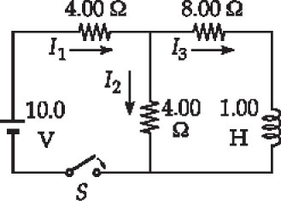

**ANS. FIG. P31.15**

From [1] and [2],

+10.0 – 4.00*i*1 – 4.00*i*1 + 4.00*i*3 = 0

*i*1 = 0.500*i*3 + 1.25 A

Then [3] becomes 



or 

which can be compared to the general form (Equation 31.6)



which has the solution (from Equation 31.7) 

Thus, we have:

(a) 

(b) 

**P31.16** Refer to ANS. FIG. P31.15 above. Name the currents as shown. By Kirchhoff’s laws:

*i*1 = *i*2 + *i*3 **[1]**

 **[2]**

 **[3]**

From [1] and [2],





Then [3] becomes





which can be compared to the general form (Equation 31.6)



which has the solution (from Equation 31.7)



Thus, we have:

(a) 

(b) 



**P31.17** From Equation 31.7, Therefore,



where



Then,  with 

(a) At *t* = 0,



(b) At *t* = 1.50 s,



**P31.18** (a) For a series connection, both inductors carry equal currents at every instant, so  is the same for both. The voltage across the pair is



(b) For a parallel connection, the voltage across each inductor is the same for both.



where the currents are related by *i* = *i*1 + *i*2. Therefore,



(c) 

Now *i* and  are independent quantities under our control, so functional equality requires both *L*eq = *L*1 + *L*2 and *R*eq = *R*1 + *R*2.

(d) Yes. The relations , where *i* = *i*1 + *i*2 and  must always be true.

We may choose to keep the currents constant in time. Then, from   
*i* = *i*1 + *i*2, we have



We may choose to make the current oscillate so that at a given moment it is zero. Then, from  as in part (b), we have .

**P31.19** For , the current in the inductor is .

For , there will be current iR in the resistor and *IL* in the inductor so that *i* = *iR* + *iL* = *Ii* = 10.0 A. Assuming both currents are downward in ANS. FIG. P31.19, we apply Kirchhoff’s loop rule going counterclockwise around the loop, and we find that



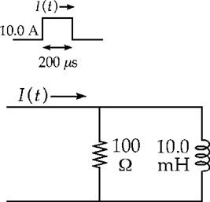

**ANS. FIG. P31.19**

Using  we have



Then,





which gives



We see that *t* = 0, *iL* = 0 as we expect because of the back emf induced in the inductor. With the time constant



we have



At *t* = 200 *µ*s,  thereafter, the current decays. The loop rule gives the same result,



but now  so we have



For *t* = 200 *µ*s, *ii* = 8.65 A, and for ,



**Section 31.3 Energy in a Magnetic Field**

P31.20 The inductance of the solenoid is



The energy stored is



**P31.21** For a solenoid of length  the inductance is 

Thus, since , the stored energy is



**P31.22** We compute the integral:



**P31.23** The current in the circuit at time t is  where  and the energy stored in the inductor is

(a) As 



(b) At 



**P31.24** (a) 

(b) 

(c) METHOD 1: We treat the real inductor as an ideal inductor (with no resistance) in series with an ideal resistor (with no inductance). When the current is 3.00 A, Kirchhoff’s loop rule reads



The power being stored in the inductor is



METHOD 2: We do not treat the real inductor as an ideal inductor in series with an ideal resistor.

We wish to find the rate at which energy is being delivered to the inductor. As discussed in Section 31.3, . We know *L* (0.040 0 H) and *i* (3.00 A); we need to evaluate the term  From Equations 31.7 and 31.8 (or Equation 31.9),



because . Also,



Therefore,



When *i* = 3.00 A,



(d) 

(e) 

(f) 

**Section 31.4 Mutual Inductance**

P31.25 We use Equation 31.17,  from which we obtain the mutual inductance:



**P31.26** (a) The mutual inductance of the coils is



(b) The inductance of coil A is



(c) The emf induced in the other coil is



**P31.27** (a) Solenoid S1 creates a nearly uniform field everywhere inside it, given by  The flux through one turn of solenoid S2 is



The emf induced in solenoid S2 is



The mutual inductance is



(b) Solenoid S2 creates a nearly uniform field everywhere inside it, given by  and nearly zero field outside. The flux through one turn of solenoid 1 is



The emf induced in solenoid 1 is



The mutual inductance is



(c) 

**P31.28** (a) A current *i* in the large loop of radius *R* produces a magnetic field of magnitude  at its center. Because the radius of the small loop *r<< R*, we may treat the flux through the small loop as being approximately  The mutual inductance of the loops is then



(b) 

**Section 31.5 Oscillations in an *LC* Circuit**

**P31.29** When the switch has been closed for a long time, battery, resistor, and coil carry constant current  When the switch is opened, current in battery and resistor drops to zero, but the coil carries this same current for a moment as oscillations begin in the *LC* loop.

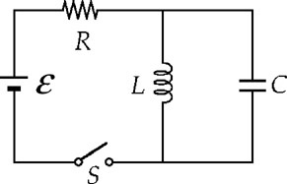

**ANS. FIG. P31.29**

We interpret the problem to mean that the voltage amplitude of these oscillations is  in 

Then,



**P31.30** Find the energy stored in the circuit:



If the energy is split equally between the capacitor and inductor at some instant, the energy would be half this value, or 200 *µ*J. Therefore, there would be no time when each component stores 250 *µ*J.

**P31.31** At different times, the maximum energy stored in the capacitor is equal to the maximum energy stored in the inductor.



so



P31.32 At t = 0 the capacitor charge is at its maximum value, so  = 0 in



Substituting the given information, the charge at 2 ms is



(a) Then the energy in the capacitor is



(c) The constant total energy is that originally of the capacitor:



(b) So the inductor’s energy is the remaining



**Section 31.6 The *RLC* Circuit**

**P31.33** (a) The frequency of damped oscillations is given by Equation 31.27: 

Therefore, .

(b) Critical damping occurs when , or when



**P31.34** We choose to call positive current clockwise in Figure 31.15. It drains charge from the capacitor according to A clockwise trip around the circuit then gives



or .

**P31.35** (a) The charge on the capacitor is given by Equation 31.26:

 so 

When the amplitude of the oscillation falls to 50.0% of its initial value, we have

 and 

Then,



(b) The initial energy of the circuit is . When *U* = 0.500U0,



Then,

 (half as long as part (a))

**Additional Problems**

**P31.36** (a) Let *Q* represent the magnitude of the opposite charges on the plates of a parallel plate capacitor, the two plates having area *A* and separation *d*. The negative plate creates an electric field  toward itself. It exerts on the positive plate force  toward the negative plate. The total field between the plates is  The energy density is  Modeling this as a negative or inward pressure, we have for the force on one plate  in agreement with our first analysis.

(b) The lower of the two current sheets shown creates above it magnetic field . Let  and *w* represent the length and width of each sheet. The upper sheet carries current J*sw* and feels force



The force per area is .

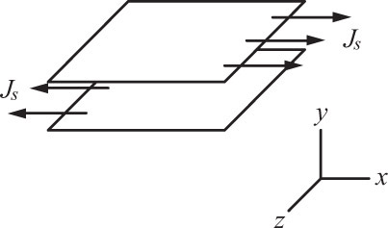

**ANS. FIG. P31.36 (b)**

(c) Between the two sheets, each sheet contributes the same field, so the total magnetic field is , with magnitude . Outside the space they enclose, the fields of the separate sheets are in opposite directions and add to 

(d) 

(e) 

**P31.37** The total energy equals the energy in the capacitor and inductor:



so 

The flux through each turn of the coil is



where *N* is the number of turns.

**P31.38** (a) The inductor has no resistance, therefore it has voltage across it. It behaves as a 

(b) The battery sees an equivalent resistance



The battery current is



The voltage across the parallel combination of resistors is



The current in the 8-Ω resistor and the inductor is



(c) The energy stored in the inductor for *t* < 0 is



(d) 

(e) See ANS. FIG. P31.38 (e). The current decreases from 500 mA toward zero, showing exponential decay with a time constant



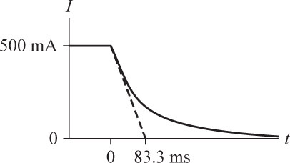

**ANS. FIG. P31.38(e)**

**P31.39** (a) At the center, 

So the coil creates flux through itself



The inductance is



(b) To find the inductance of the circuit, we compute its radius from



Then, from the expression found in part(a), the inductance is



(c) The time constant is

 

**P31.40** (a) Initially, the current is zero because of the emf induced in the coil resists an increase in the current. Just after the circuit is connected, the potential difference across the resistor is 0 and the emf across the coil is 24.0 V.

(b) After several seconds, the current has reached a steady value and does not change. After several seconds, the potential difference across the resistor is 24.0 V and that across the coil is 0.

(c) The resistor voltage and inductor voltage always add to 24 V. The resistor voltage increases monotonically, so the two voltages are equal to each other, both being 12.0 V, just once. The time is given by



Substituting,





(d) There is now no battery in the circuit, so the current decays to zero. The resistor and inductor are in parallel because they have common connections on each side. As the current decays the potential difference across the resistor is always equal to the emf across the coil.

**\*P31.41 Conceptualize** The inductance of the toroid will depend on the dimensions of the wooden ring. In turn, the energy stored in the inductor will depend on the inductance.

**Categorize** This problem involves a calculation of the inductance of a closelyspaced coil.

**Analyze** Identify a small element of the torus of radius *r* and thickness *dr*, as shown in the diagram, below:

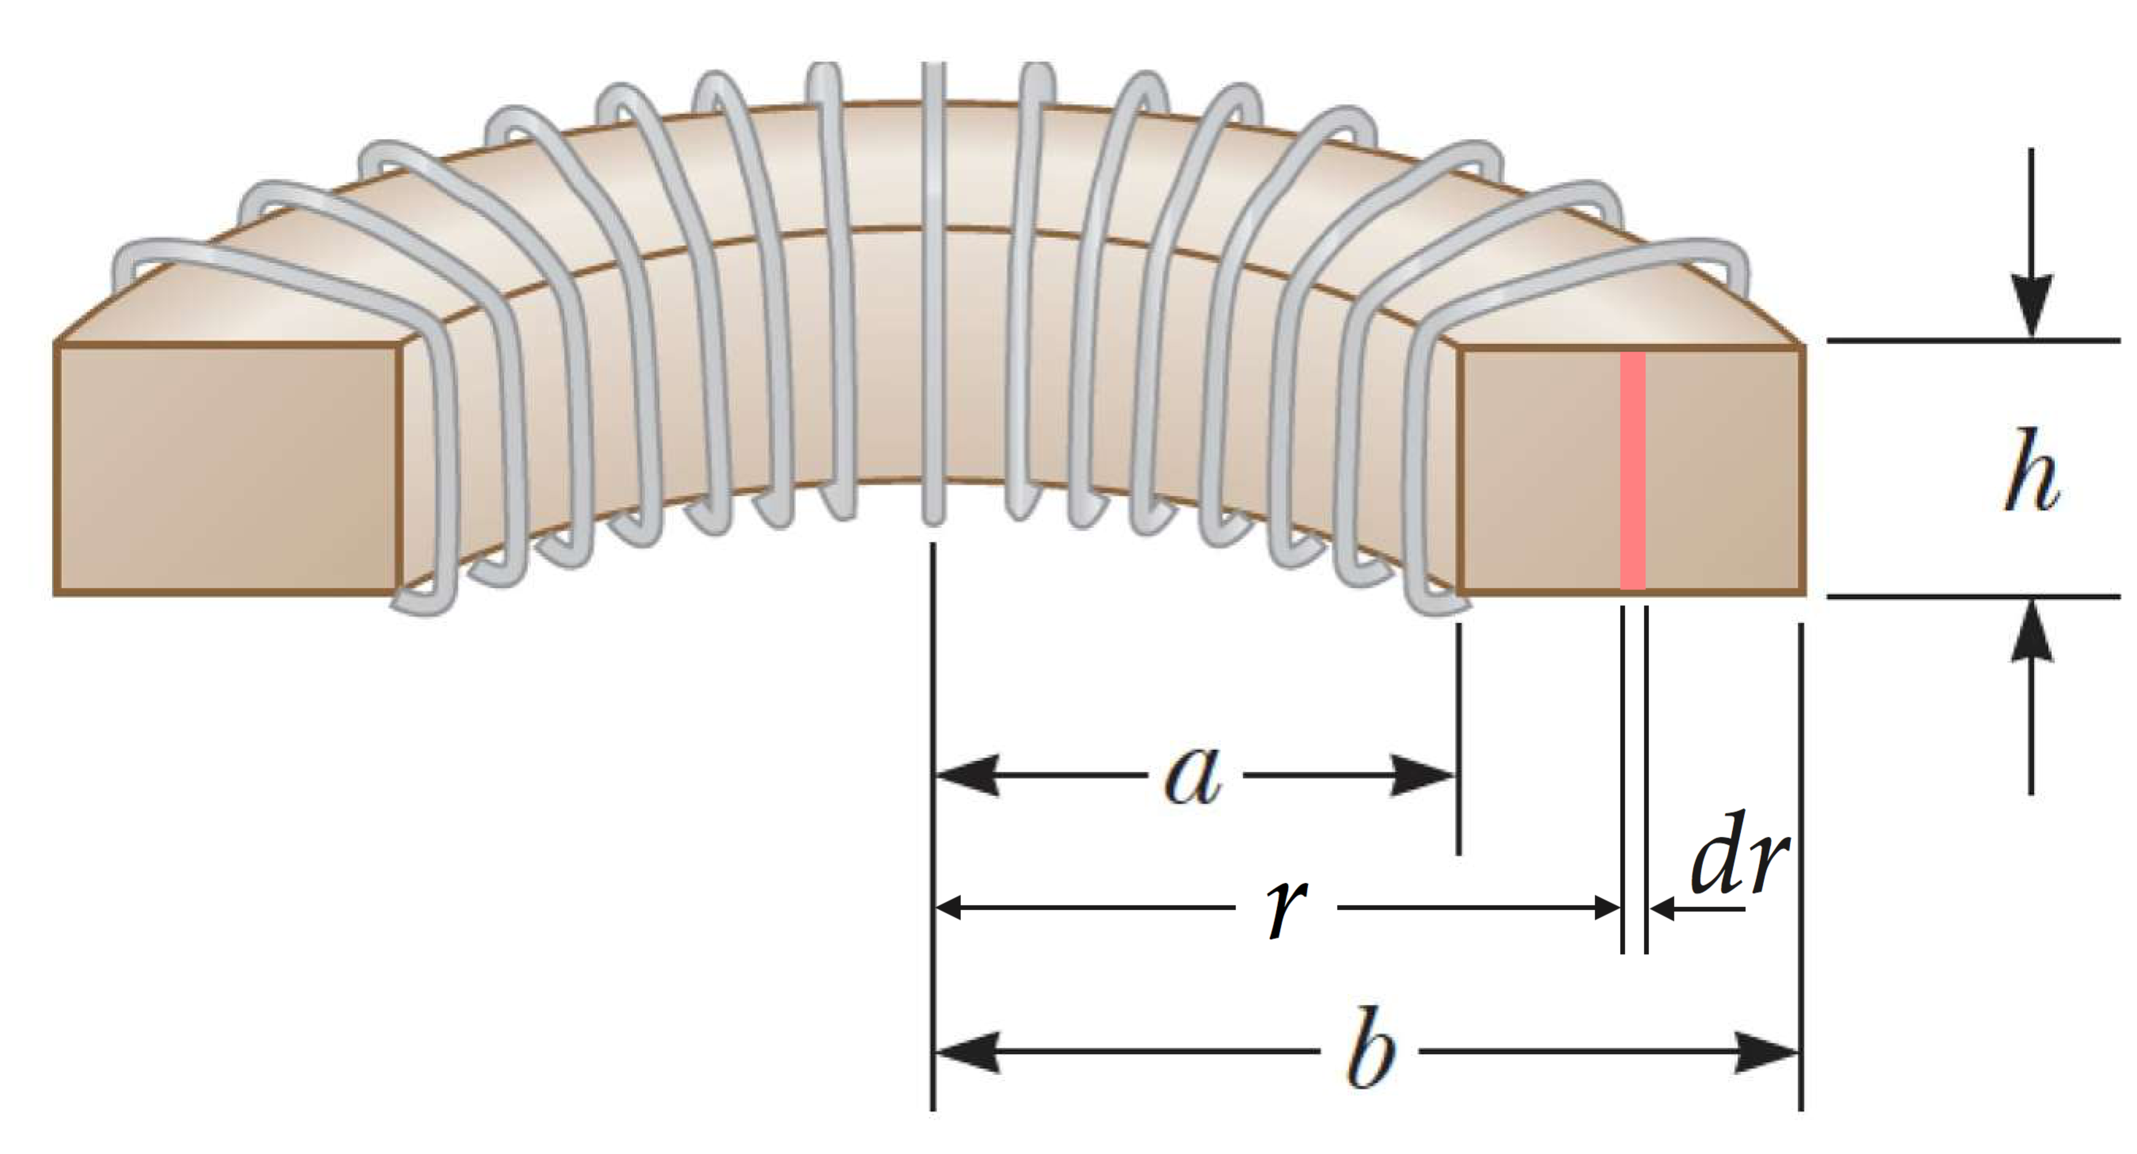

From Example 29.6, we know that the magnetic field inside a toroid is given by

 (1)

where *i* is the time-varying current in the inductor. From Equation 29.18, the magnetic flux through the rectangular cross section of the torus is

 (2)

Recognize that the magnetic field is perpendicular to each cross-sectional element and substitute Equation (1) into Equation (2):

 (3)

Then, from Equation 31.2, the inductance of the toroidal inductor is

 (4)

Then, from Equation 31.12, the energy stored in the inductor is

 (5)

Solve Equation (5) for the ratio *b*/*a*:



Substitute numerical values:



**Finalize** Notice that we found the ratio *b*/*a* without knowing either *b* or *a*. Therefore, you are free to choose an outer radius *b* that is convenient in size for your experiment. Then the result of the problem will determine the value of *a* to be used to cut the wooden ring.

*Answer:*1.20

**\*P31.42 Conceptualize** The inductance of the toroid will depend on the dimensions of the wooden ring. In turn, the energy stored in the inductor will depend on the inductance.

**Categorize** This problem involves a calculation of the inductance of a closelyspaced coil.

**Analyze** Identify a small element of the torus of radius *r* and thickness *dr*, as shown in the diagram, below:



From Example 29.6, we know that the magnetic field inside a toroid is given by

 (1)

where*i* is the time-varying current in the inductor. From Equation 29.18, the magnetic flux through the rectangular cross section of the torus is

 (2)

Recognize that the magnetic field is perpendicular to each cross-sectional element and substitute Equation (1) into Equation (2):

 (3)

Then, from Equation 31.2, the inductance of the toroidal inductor is

 (4)

Then, from Equation 31.12, the energy stored in the inductor is

 (5)

Solve Equation (5) for the ratio *b*/*a*:



**Finalize** Notice that we found the ratio *b*/*a* without knowing either *b* or *a*. Therefore, you are free to choose an outer radius *b* that is convenient in size for your experiment. Then the result of the problem will determine the value of *a* to be used to cut the wooden ring.

*Answer:*

**\*P31.43 Conceptualize** We see our familiar circuit elements: battery, resistor, inductor, an and capacitor, but in a combination that we have not seen before. Let’s analyze the circuit carefully in the Categorize step.

**Categorize** With the switch in position *a*, the outer loop is an *RL* circuit. We’ve seen this before. Because the switch has been at position *a* for a long time, the current has reached its maximum value. When the switch is thrown to position *b*, the battery is removed and the right-hand loop is an *LC* circuit. We’ve seen this before, too.

**Analyze** Begin by finding the current in the circuit with the switch at position *a*:

 (1)

where we have recognized that the inductor has no effect on the circuit because the current is not changing. Now, we throw the switch to position *b*, creating an *LC* circuit. Energy will oscillate between the inductor and the capacitor. There will be no loss of energy because of the absence of resistance in the *LC* circuit, so

 (2)

In the oscillations of the *LC* circuit, the capacitor begins with zero charge. Therefore, the appropriate solution to Equation 31.20 is

 (3)

where ** is given by Equation 31.22:

 (4)

Combine Equations (1) to (4):

 (5)

Substitute numerical values:



The negative sign on the answer indicates that the polarity of the capacitor is the opposite of the polarity that it has just after *t* = 0. Because our convention is to present the charge on the capacitor as a positive number, the charge on the capacitor is ***q* =** .

**Finalize** In Figure P31.43, we see that the upper plate of the capacitor is charged positively when the switch is in position *a*. The current in the inductor is downward. When the switch is thrown to position *b*, the circuit consists only of the right-hand loop with the inductor and capacitor. The inductor attempts to maintain the clockwise current in the loop, thereby delivering positive charge to the lower plate of the capacitor. As a result, the polarity of the capacitor reverses, consistent with the negative sign in Equation (6).

*Answer:* 3.67 × 10–5C

**P31.44** We calculate the angular frequency of the circuit from Equation 31.27:



The fact that the angular frequency at which the circuit oscillates is zero tells you that the circuit is critically damped. There will be no decaying oscillations. The critical resistance is given by



which is just the resistance that you are using for your experiment

**P31.45** The emf across the inductor is given by



where the rate of change of current  isin amperes per second (A/s), and the induced emf  is in millivolts (mV).

Between *t* = 0 and *t* = 1 ms:   = –100 mV

Between *t* = 1 ms and *t* = 2 ms:   = 0

Between *t* = 2 ms and *t* = 3 ms:   = –50 mV

Between *t* = 3 ms and *t* = 5 ms:   = +75 mV

Between *t* = 5 ms and *t* = 6 ms:   = 0

The graph of  is shown in ANS. FIG. P31.45.

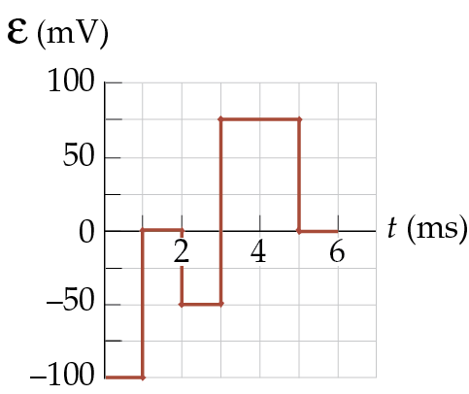

**ANS. FIG. P31.45**

**P31.46** (a) 

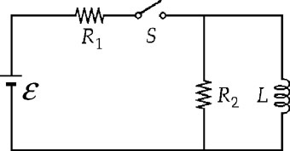

**ANS. FIG. P31.46**

(b) For the left-hand loop,



(c) For the outside loop,



(d) Substitute the equation for *i*1 from part (a) into the equation in part (b):



Substitute the equation for *i*1 from part (a) into the equation in part (c):



Equate the two expressions for *i*2:



Expanding and solving,





And finally,



Calling  and , the equation for *i* can be written



(e) This is of the same form as the Equation 31.6 in the text for a simple *RL* circuit, so its solution is of the same form as Equation 31.7:



where



Thus,

 where 

**P31.47** Find the current in the cylinder.



From Ampère’s law,



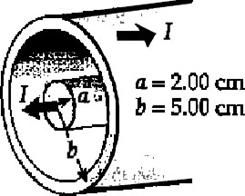

**ANS. FIG. P31.47**

(a) At *r* = *a* = 0.020 0 m,  and



(b) At *r* = *b* = 0.050 0 m,  and



(c) The energy density is 



(d) The magnetic field created by the inner conductor exerts a force of repulsion on the current in the outer sheath. The strength of this field, from part (b), is 20.0 mT. Consider a small rectangular section of the outer cylinder of length  and width *w*.

It carries a current of 

and experiences an outward force



The pressure on it is  

**P31.48** (a) The magnetic field inside the solenoid is given by 





ANS. FIg. P31.48

(b) The energy density of the magnetic field is



(c) 

(d) The field of the windings is upward and radially outward around the top of the solenoid. It exerts a force radially inward and upward on each bit of the clockwise supercurrent. The total force on the supercurrents in the bar is upward. You can think of it as a force of repulsion between the solenoid with its north end pointing up, and the core, with its north end pointing down.

(e) 

Note that we have not proved that energy density is pressure. In fact, it is not in some cases.

**P31.49** From Ampère’s law, the magnetic field at distance  is found as:

, or 

The magnetic energy per unit length within the wire is then



This is independent of the radius of the wire.

**Challenge Problems**

**P31.50** (a) 

(b) 

(c) When the wires carry current *i*, magnetic flux passes through the rectangle bordered by the wires (surface to surface of the wires):



where *y* is measured from the center of the lower wire, *dA* is a rectangular area element of length *x* and width *dy*, and *B* is the magnitude of the net magnetic field generated by the upper and lower wires that passes through *dA*. The inductance is



We can simplify this calculation by noting that by the symmetry of the arrangement, each conductor contributes equally to the field that passes through the area between them. Thus, the total inductance of both wires is twice the inductance of one wire. The inductance due to the lower wire is



The inductance due to both wires is twice this: .

**P31.51** The total magnetic energy is the volume integral of the energy density,



Because *B* changes with position, *uB* is not constant. For ,



Next, we set up an expression for the magnetic energy in a spherical shell of radius *r* and thickness *dr*. Such a shell has a volume , so the energy stored in it is



We integrate this expression for *r* = *R* to  to obtain the total magnetic energy outside the sphere. This gives



Substituting numerical values,



**P31.52** (a) While steady-state conditions exist, a 9.00 mA flows clockwise around the right loop of the circuit. Immediately after the switch is opened, a 9.00 mA current will flow around the outer loop of the circuit. Applying Kirchhoff’s loop rule going clockwise around this loop gives:



(b) Starting at point *a*, the potential rises across the inductor then falls across resistors *R*2 and *R*1. The positive answer in part (a) means that  is the higher potential.

(c) The currents in R1 and R2 are shown in ANS. FIG. P31.52 (c).below. After t = 0, the current in R1 decreases from an initial value of   
9.00 mA according to i = I*i*e–Rt/L. Taking the original current direction as positive in each resistor, the current decreases from +9.00 mA (to the right) to zero in R1. In R2 the current jumps from +3.00 mA (downward) to –9.00 mA (upward) and then decreases in magnitude to zero. The time constant of each decay is 0.4 H/8 000  = 50 *µ*s. Thus we draw each current dropping to 1/e = 36.8% of its original value = 3.3 *µ*A at the 50 *µ*s instant.

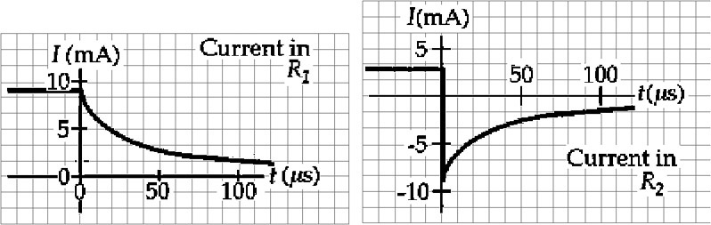

**ANS. FIG. P31.52 (c)**

(d) After the switch is opened, the current around the outer loop decays as



with *Ii* = 9.00 mA, *R* = 8.00 kΩ, and *L* = 0.400 H.

Thus, when the current has reached a value *i* = 2.00 mA, the elapsed time is:



**P31.53** With *i* = *i*1 + *i*2, the voltage across the pair is:

 **[1]**

and

 **[2]**

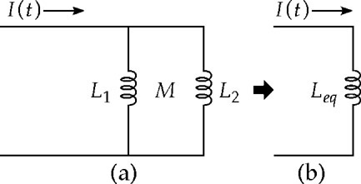

**ANS. FIG. P31.53**

So, from [1], we have



which, when substituted into [2], gives



 **[3]**

From [2], 

which, when substituted into [1], gives



 **[4]**

Adding [3] to [4], we have



So, 

|  |
| --- |
| **ANSWERS TO QUICK-QUIZZES** |

1. (c), (f)
2. (i) (b) (ii) (a)
3. (a), (d)
4. (a)
5. (i) (b) (ii) (c)

|  |
| --- |
| **ANSWERS TO EVEN-NUMBERED PROBLEMS** |

**P31.2** 1.36 *μ*H

**P31.4** (a) 188 *µ*T; (b)  (c) 0.375 mH; (d) *B* and  are proportional to current: *L* is independent of current.

**P31.6** See P31.6 for full explanation.

**P31.8** See ANS. FIG. P31.8.

**P31.10** (a)  (b) 

**P31.12** See P31.12 for full explanation.

**P31.14** (a) 36.0  (b) 1.14 kH

**P31.16** (a)  (b) 

**P31.18** (a) See P31.18 (a) for full explanation; (b) See P31.18 (b) for full explanation; (c) See P31.18 (c) for full explanation; (d) Yes. See P31.18 (d) for full explanation.

**P31.20** 64.8 mJ

**P31.22** 

**P31.24** (a) 66.0 W; (b) 45.0 W; (c) 21.0 W; (d) The power supplied by the battery is equal to the sum of the power delivered to the internal resistance of the coil and the power stored in the magnetic field;   
(e) Yes; (f) Just after *t* = 0, the current is very small, so the power delivered to the internal resistance of the coil (*iR*2) is nearly zero, but the rate of the change of the current is large, so the power delivered to the magnetic field (*Ldi/dt*) is large, and nearly all the battery power is being stored in the magnetic field. Long after the connection is made, the current is not changing, so no power is being stored in the magnetic field, and all the battery power is being delivered to the internal resistance of the coil.

**P31.26** (a)  (b)  (c) 

**P31.28** (a) See P31.28 (a) for full explanation; (b) 3.95 nH

**P31.30** If the energy is split equally between the capacitor and inductor at some instant, the energy would be half this value, or 200 *µ*J. Therefore, there would be no time when each component stores 250 *µ*J.

**P31.32** (a) 6.03 J; (b) 0.529 J; (c) 6.56 J

**P31.34** See P31.34 for full explanation.

**P31.36** (a) See P31.36(a) for full explanation; (b) ; (c) , zero;   
(d) ; (e) The energy density found in part (d) agrees with the magnetic pressure found in part (b).

**P31.38** (a) short circuit; (b) 500 mA; (c) 125 mJ; (d) The energy becomes 125 mJ of additional internal energy in the 8-Ω resistor and the 4-Ω resistor in the middle branch; (e) See ANS FIG P31.38(e).

**P31.40** (a) Just after the circuit is connected, the potential difference across the register is 0, and the emf across the coil is 24.0 V; (b) After several seconds, the potential difference across the resistor is 24.0 V and that across the coil is 0; (c) The two voltages are equal to each other, both being 12.0 V, just once, at 0.578 ms after the circuit is connected; (d) As the current decays, the potential difference across the resistor is always equal to the emf across the coil.

**P31.42** 

**P31.44** See P31.44 for full explanation.

**P31.46** (a) *i*1 = *i*2 + *i*; (b)  (c)   
(d)  (e) See P31.46(e) for full explanation.

**P31.48** (a) 2.93 mT; (b) 3.42 Pa; (c) The supercurrents must be clockwise to produce a downward magnetic field to cancel the upward field of the current in the windings; (d) The field of the windings is upward and radially outward around the top of the solenoid. It exerts a force radially inward and upward on each bit of the clockwise supercurrent. The total force on the supercurrents in the bar is upward; (e) 1.30 mN

**P31.50** (a) It has a magnetic field, and it stores energy, so  is non-zero; (b) Every field line goes through the rectangle between the conductors; (c) See P31.50 (c) for full explanation.

**P31.52** (a) 72.0 V; (b) point b; (c) See ANS. FIG. P31.52 (c); (d) 75.2 *µ*s